West Virginia University
The Student Assembly - Student Government Association
Assembly Resolution: AR-2023-12-01
AN ASSEMBLY RESOLUTION ENCOURAGING WVU ADMINISTRATORS AND LOCAL OFFICIALS TO ADDRESS THE CONCERNS IDENTIFIED IN THE FALL 2023 SAFETY AND ACCESSIBILITY WALK

Short Title: | Safety and Accessibility Walk Report
Author(s): | Matthew Olivero, Senator  Gabrielle Frazier, Senator  Carter Leadmon, Senator
Sponsor(s): | Joanna Switala, College Senator (Eberly)  Peyton Bielinski, College Senator (CAHS)  Elijah Eastman, Senator  Olivia Schmieder, College Senator (Davis)  Daniel Madden, College Senator (Chambers)
Contributor(s): | Drew Gatlin, Staff Engineer, City of Morgantown  MJ Jones, Apprentice  Tris Silva, Apprentice  Savannah Guzzi-Graber, Apprentice  Charles C. Long, Chief of Staff  Hayley Day, Local Government Liaison
Committee Endorsement: | Student Life
First Reading Date: | 12/6/2023
Second Reading Date: | N/A–Request to Fast-Track
Date of Approval:
Presidential Signature:
Whereas, West Virginia University is “dedicated to providing a safe learning, working, and living environment for [its] students, faculty, staff, and visitors;”

Whereas, the West Virginia University Student Government Association mission statement reads, “We, the students of West Virginia University, desire to…help ensure that the personal freedoms and general welfare of the students within our University are protected;” and,

Whereas, Board of Governors rule 1.6 prohibits discrimination, including: “failure to provide reasonable accommodation, consistent with state and federal law, to persons with disabilities;” and,

Whereas, according to the Centers for Disease Control and Prevention, motor vehicle-related pedestrian deaths have risen year-over-year since 2018; and,

Whereas, in 2021 (the most recent year with data), West Virginia ranked in the top half of states in pedestrian fatality rate per 100,000 people; and

Whereas, Morgantown had seven fatal motor vehicle crashes and two fatal crashes involving pedestrians in 2021; and,

Whereas, the WV Department of Transportation’s recently published Vulnerable Road User Assessment found that Morgantown was grossly overrepresented in both the High Injury Network and Systemic (Risk) Analysis, containing 20% of the state’s top High Injury Network segments and 12 of the 25 riskiest road segments for pedestrians and cyclists; and,

Whereas, in the fall of 2023, WVU SGA conducted a survey for the purpose of understanding student sentiment towards safety and accessibility in the City and University; and,

Whereas, on October 17th, 2023, the West Virginia University Student Government Association conducted the Fall 2023 Safety and Accessibility Walk, covering areas including the downtown campus, Sunnyside, and Evansdale; and,

Whereas, participants in the walk cataloged concerns relating to accessibility, lighting, crosswalks, sidewalks, blue lights, and other safety concerns; and,

Therefore, be it resolved by the Student Assembly of West Virginia University:

Section 1: recommends that the University and City of Morgantown investigate and address the safety and accessibility concerns detailed in Appendix A: Safety and Accessibility Walk Report.

Section 2: requests that the University and the City provide regular updates on the status of the concerns outlined in the report, as well as any future plans to address them.

Section 3: Upon passage and approval, this legislation shall be forwarded to:

Mandates:
G. Corey Farris, Dean of Students
Dr. Thanh Le, Director, Student Engagement and Leadership
Carrie Showalter, Assistant Dean of Students
Ted Svehlik, Associate Vice President, Auxiliary and Business Services
Sam Miller, Maintenance Director, WVU Facilities and Services
Chuck Roberts, Assistant Vice President, WVU Facilities and Services
Ron Justice, Director, Local Government Relations
Sherry St. Clair, Chief, University Police Department
Jill Hess, ADA Coordinator, Division of Diversity, Equity, and Inclusion
Tris Cendana, Executive Director, WVU Housing and Residence Life
Drew Gatlin, Staff Engineer, City of Morgantown
Matthew Cross, Morgantown Pedestrian Safety Board
M. Joe Abu-Ghannam, 1st Ward, Morgantown City Council
Bill Kawecki, 2nd Ward, Morgantown City Council
Louise Michael, 3rd Ward, Morgantown City Council
Jennifer Selin, Mayor, City of Morgantown
Danielle Trumble, 5th Ward, Morgantown City Council
Dave Harshbarger, 6th Ward, Morgantown City Council
Brian Butcher, 7th Ward, Morgantown City Council
Daily Athenaeum
Madison Santmyer, Student Body President
Karsey Prichard, SGA Executive Secretary

APPENDIX A – SAFETY AND ACCESSIBILITY WALK REPORT

Executive Summary
On October 17th, 2023, the West Virginia University Student Government Association conducted the Fall 2023 Safety and Accessibility walk in coordination with relevant stakeholders from the University, City, and State of West Virginia. The walk was divided into three sections: the downtown campus, Sunnyside, and the Evansdale Campus. Findings of deficiencies relating to safety and accessibility were made in each of these sections, and those findings are summarized in this report. As with the Spring 2023 walk, participants cataloged their findings by using the QuickCapture app; accordingly, the full database of reports can be found here. In all, there were a total of 308 reports: 265 categorized and 43 uncategorized. In many cases, findings were made that are of high priority; those findings are bolded for convenience. While the walk was a success in terms of participation and reporting, the authors believe it is crucial for the City and University to develop more comprehensive assessment and reporting plans for safety and accessibility deficiencies, so that student involvement can shift from a need to a luxury.

Collection Process
Electronic field reporting using geolocated photos – developed by the City of Morgantown and first deployed in the Spring 2023 walk and used again for the Fall 2023 walk – continues to have dramatic effects on the complaint submission and reporting process. The most obvious of these effects is an increase in the number of reports submitted. Previous walks generated, on average, several dozen reports for each event. The Fall 2023 walk generated over 300 combined reports – nearly 90% of which were submitted using the custom ArcGIS QuickCapture app.

Data Overview
Fall 2023 participants covered three main areas – downtown campus, the Sunnyside neighborhood, and the Evansdale campus. The Evansdale and downtown campus areas are frequently covered in safety walks; the Sunnyside area hadn’t been covered in at least several years. The downtown campus area was expanded to include nearby residential areas north of Willey Street and was ultimately covered by two separate groups due to the large geographic size and high density of sidewalks and trails present. All three areas have roads and other infrastructure owned / maintained by several different agencies, though in general the campus areas lean toward WVU / State maintained roads and infrastructure, and the Sunnyside area leans toward City/State maintained roads and infrastructure.

The nature of the walks is infrequent, dependent on voluntary participation, and hosted by revolving student government administrations. Therefore, readers must understand that the collection of reports from any given walk cannot be considered a systematic or comprehensive examination of existing conditions or trends in covered areas. Where time allowed and memory served, the author of this report included context from previous walks (ex. comparisons of report types, whether a report had been previously submitted), current and imminent construction projects, and previous planning documents including the 2020 MMMPO Regional Bike and Pedestrian Transportation Plan.

A Preliminary Note on Sidewalk Repair
In general, federal guidelines mandate that pedestrian facilities like sidewalks and crosswalks must be brought up to relevant standards when they are newly constructed or altered. There are two major standards that apply: the Public Rights-of-Way Accessibility Guidelines generally to sidewalks along streets, and the Americans with Disabilities Act Accessibility Guidelines for Buildings and Facilities generally to sidewalks that provide access to buildings and other structures. However, there are no universal guidelines applicable to set thresholds for sidewalk repair out of sequence with other planned construction activities.

The Federal Highways Administration (FHWA) notes that municipalities and other agencies tend to have custom or ad-hoc thresholds for repair informed by political will and a general sense of liability and risk. For communities with aging networks, they concede that the efforts to inspect and prioritize sidewalk defects require significant resources. However, they implore communities to:

“…develop and adopt sidewalk inspection and maintenance policies if guidelines, standards and policies do not already exist. At a minimum, inspections should consider changes in level, changes in grade, excessive cross-slopes (including cross slopes at driveways), vertical clearances, maximum running grades, minimum clear width and the distance protruding objects extend into the pedestrian path.”

The reference above provides excellent examples and a general process overview of developing community inspection programs and establishing specific thresholds. As shown by the growing number and regularity of defect reports in the city, area officials should strongly consider developing a standard of mutually agreed thresholds and a systematic and community-wide method to identify and address sidewalk defects.

Participants generated nearly 150 observations of cracks and other deterioration in area sidewalks, forming more than half of all reports submitted in October. They were equally distributed across the three focus areas and featured a mix of sidewalks that sit along streets, sidewalks that sit next to buildings, and sidewalks that connect buildings and other structures across properties. Morgantown’s sidewalk networks are aging and subject to extreme forces as frequent and extended freeze-thaw cycling and mature tree roots. Spot deterioration is widespread and noted in all regional plans.
Some photos, such as most of the 13 reports around the Creative Arts Center – did not appear to show clear violation of this threshold. In these cases, cracks should be monitored and remediated as appropriate.
Others, though demonstrating legitimate hazards, will be addressed by ongoing projects. For example, around 17 reports submitted on Campus Drive between Beechurst and McLane will be addressed by the WVDOH Beechurst Widening and Campus Drive Intersection Reconfiguration.
In other cases, repairs should be prioritized, programmed, and performed as soon as practicable. These cases are outlined–inexhaustively–within the geographic reports below.

Reports From the Downtown Campus

Accessibility Reports
- Formalize both ramps to crosswalk on University Avenue at Colson Hall
- Pedestrian crosswalk buttons unresponsive at Campus/University/Stewart intersection
  - This is a report of very high importance; the issue has existed for at least the past year, and there have been several accidents involving pedestrians at this intersection. There is reduced visibility at this location caused by the meeting of the upward sloping Campus Drive and University Avenue.
- Improper / inaccessible pedestrian detour for sidewalk closures on Beechurst and Campus Dr. related to intersection realignment work.
  - Poor and incomplete advance signage. Reports of WVU OAS shuttling specific students do not fully address Public Right-of-Way Accessibility Guidelines failures.

Lighting Reports
There were a number of lighting reports on the Downtown Campus and adjacent neighborhoods. While the totality of these reports can be found within the complete database, some of the general trends are summarized.
- Additional lighting requested along Campus Drive between University Ave and Beechurst Ave.
  - This area is regularly trafficked by students at most hours, as it is surrounded by academic buildings and student housing.
- Additional lighting requested on Beechurst Avenue sidewalk below Eisland Hall
  - This area is almost completely devoid of any lighting infrastructure
- Additional lighting and lighting repairs requested on Spruce Street north of Prospect St., Wiles St., and Fife St. between Spruce and N High Streets.
  - These areas are both lacking in sufficient physical lights, and characterized by a high rate of nonfunctional lights.

Sidewalk Reports
There were numerous discrete sidewalk reports—some rising to the actionable level and others not. The main trends are summarized, and it is noted that the area of Campus Drive below McLane Avenue will be undergoing realignment so reports in that area are not included here.
- There is a general deterioration of sidewalks along Spruce Street and Fife Street in the areas north of Prospect St.
  - Around 10 reports were made in this region alone.
- Repairs are requested on the Campus Drive sidewalk above McLane Avenue
- There are some large cracks and deterioration on the sidewalks along Hough St.

Crossing Reports

Participants requested re-establishment of a marked crossings at the intersection of University Avenue and Willey St.
  - State road maintenance failed to re-mark at least one crossing here after resurfacing. Participants submitted requests for two to cross each leg of this complicated intersection.
  - This is a heavily trafficked crossing, especially at night. Lighting is uneven and sightlines are generally poor.
  - Additionally, a flashing crossing sign at each side of the crossing is requested to improve pedestrian visibility and facilitate the safe and efficient crossing of the two streets.
- City officials should reexamine Prospect St and North High St. intersection
  - The sidewalks and curb ramps at this doglegged intersection were recently reconfigured due to underground utility constraints. Although the changes improved certain aspects of accessibility, there is no longer a clear accessible route to cross North High at Boreman Hall nor to cross the west side of Prospect at North High. The new accessible crossings are either offset from the old crossing locations, are incomplete (lacking markings and/or ramps), or both.
- Additional crosswalk markings requested at:
  - Price crossing Prospect
  - Willey crossing Price
  - Willey crossing Prospect
  - Spruce crossing Wiles
  - Fife crossing Spruce

Reports from Sunnyside

Accessibility Reports
There were no specific accessibility reports made in Sunnyside, likely due to the inherently inaccessible nature of the terrain in that region.

Lighting Reports
- There is a series of burnt-out lights along 6th St., beginning at the intersection with Grant Avenue and continuing until the intersection with Beverly Avenue.
- There is a light out on Beechurst Avenue across from 4 ½ St.

Sidewalk Reports
There are several Sunnyside areas with sidewalks in need of repair.
- The SW corner of the intersection of McLane & 6th, extending down both streets for half a block (abutting private residential property)
  - This sidewalk is massively deteriorated and being encroached upon by grass.
- The southside of Beechurst between 6th and 5th (abutting City-owned property)
- The west side of University Avenue between Houston Drive and 1st Street (abutting commercial properties)
  - This area is highly trafficked and characterized by narrow sidewalks with sizable cracks and an uneven surface.

Crossing Reports
There were no reports or requests made in the Sunnyside area, although the authors of this report believe it is important to either add a crossing on University Avenue crossing 1st St, or add flashing crossing signs at the crosswalk on University Ave/Carson St, as this section of University Avenue is crossed with regularity and vehicle traffic is heavy throughout the day.

Reports from Evansdale

Accessibility Reports
- Request for an accessible path from the CAC to Evansdale Crossing/Bus Stop
- Request for ramps near the southwest corner of Oakland Hall

Lighting Reports
- There are multiple blue lights with functioning machines but broken lights, including at the Southwest corner of Bennett Tower and between the Rec Center and the Rec Fields.
- The University should consider adding on the footpath leading from the Advanced Engineering Research Building to the Towers PRT station, as well as between the CAC lot entrance and Fine Arts Drive.

Crossing Reports
- The University should study the crosswalk at the intersection of Fine Arts Drive and Evansdale Drive to determine if there are upgrades which could better handle the regular vehicle/pedestrian congestion present during weekday daytime hours

Sidewalk Reports
Participants submitted around 70 requests for sidewalk repair in the Evansdale area:
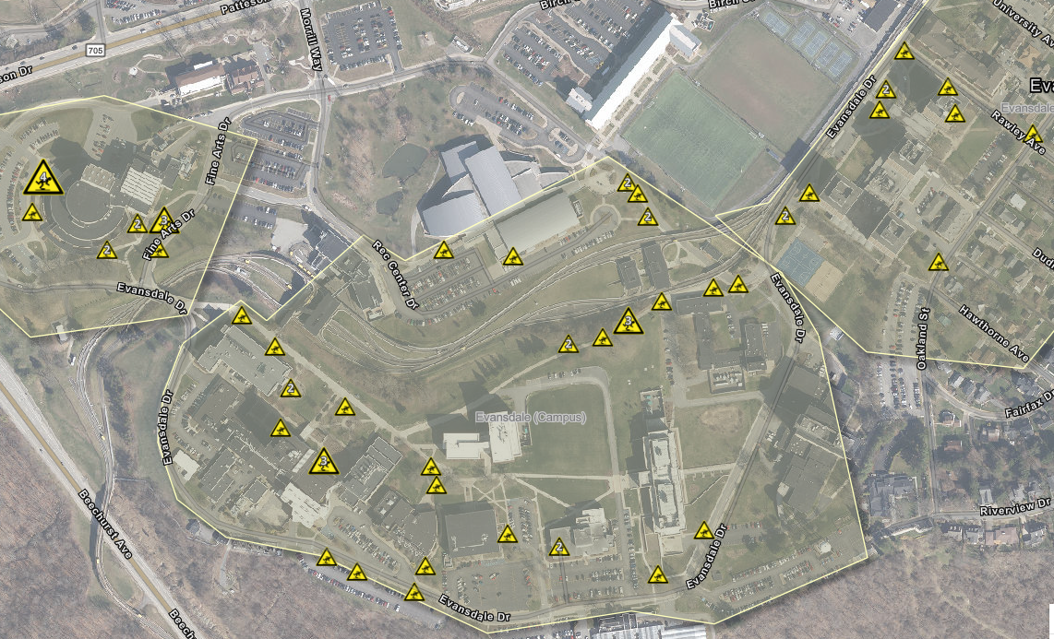
All requests for new sidewalks submitted in October came from the Evansdale area. These 12 reports can be summarized as follows:
- A large gap in the sidewalk on Evansdale Dr. between Parking Area 41 and Parking Area 40
- Desire path between Parking Area 44 and Parking Area 43
- Desire path on the west side of Evansdale Dr. near CAFEE
- A small gap connecting the sidewalk on Oakland St. to the walkway / staircase behind Lyon Tower on the north side of Parking Area 50
- A desire for a path on the north side of Rawley Ave. between Oakland St. Parking Area 58
- Gaps on Oakland St. and Harding St. between University Avenue and the dense student housing to the northeast
The Oakland/Harding/University Avenue intersections near the Evansdale McDonald’s serve as main pedestrian crossroads between the HSC, Law School, and Evansdale campuses. They sit next to dense student housing and major developments seen in the area over the past decade (Pierpont Place/University Park and surrounds). They often host hundreds of pedestrians per hour throughout each weekday and on all football game days. Pedestrian/vehicular conflict is common at the City-owned Oakland/University signalized intersection.
- City officials should follow through with their commitment to implement a Leading Pedestrian Interval into the signal timing pattern at Oakland/University.
- City and WVU officials should work together to fill the gaps in the sidewalk and lack of marked crossings on Oakland St. between the Evansdale McDonald’s and West Everly St.
- City officials should reexamine their Harding Avenue streetscape plans and seek partners to bring those plans to reality. Those upgrades should fill gaps in the sidewalk network on Harding Ave. between Oakland Hall and Oakland St.
- City should better maintain crosswalk markings eradicated by utility work, such as the four at the Oakland/University intersection.

APPENDIX B – SAFETY AND ACCESSIBILITY SURVEY
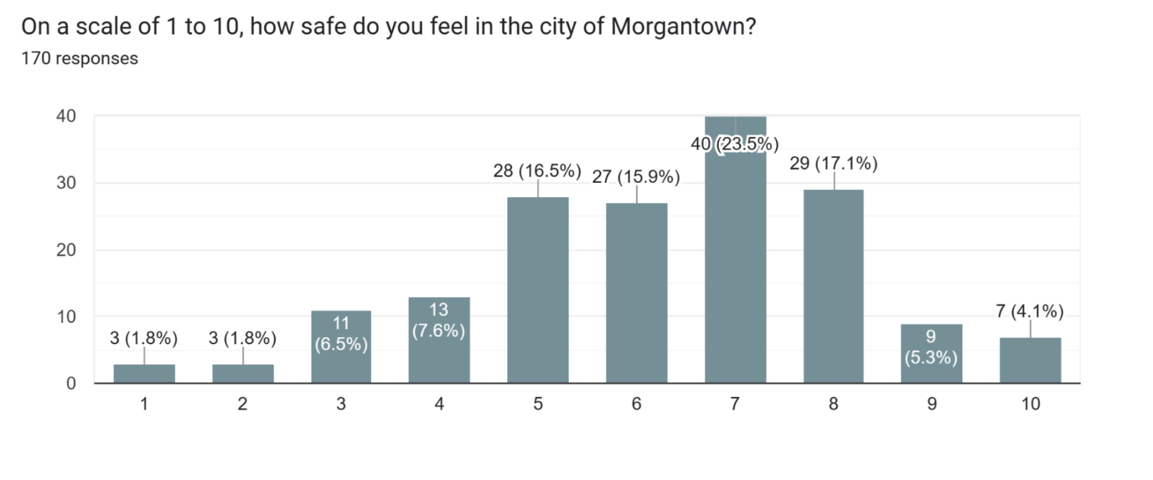
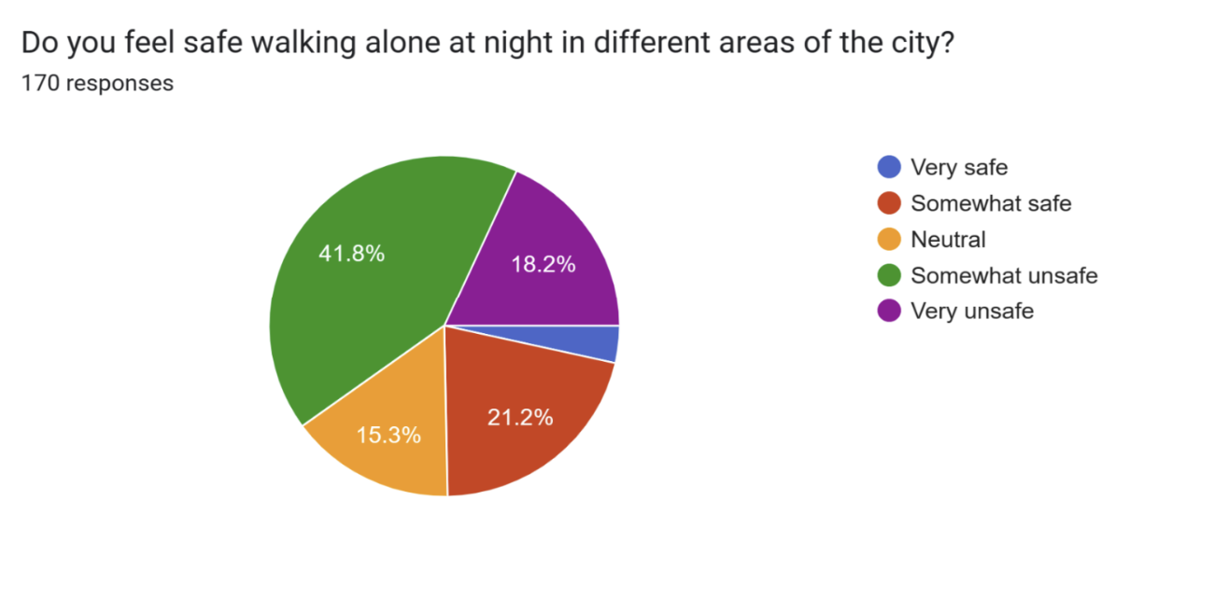
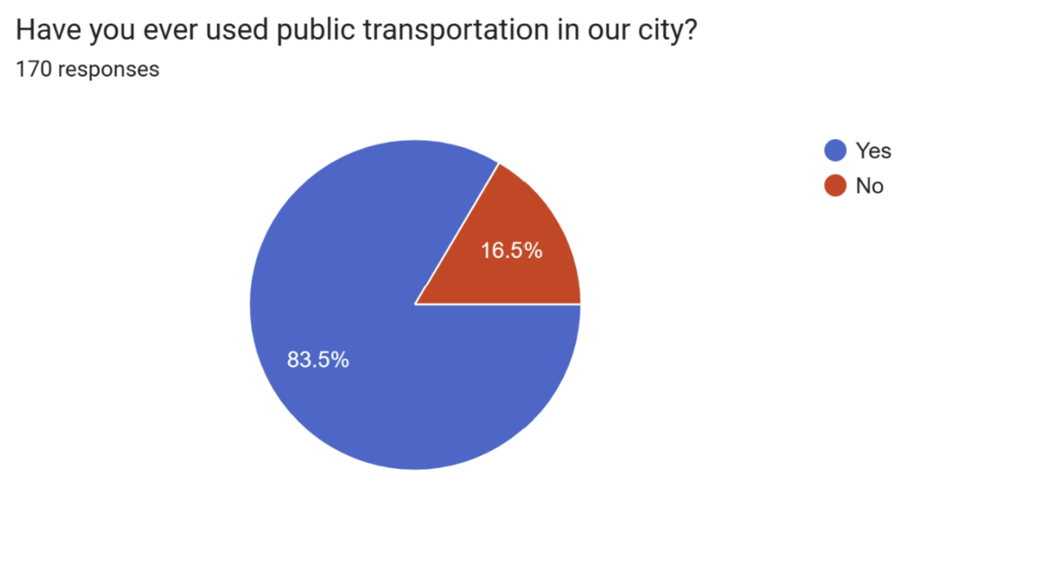
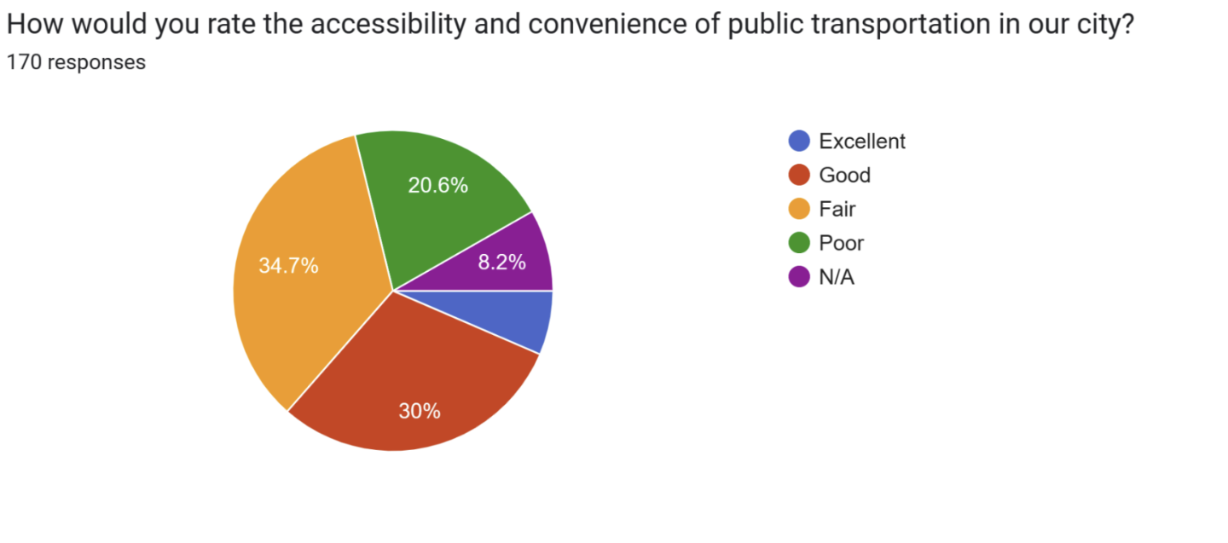

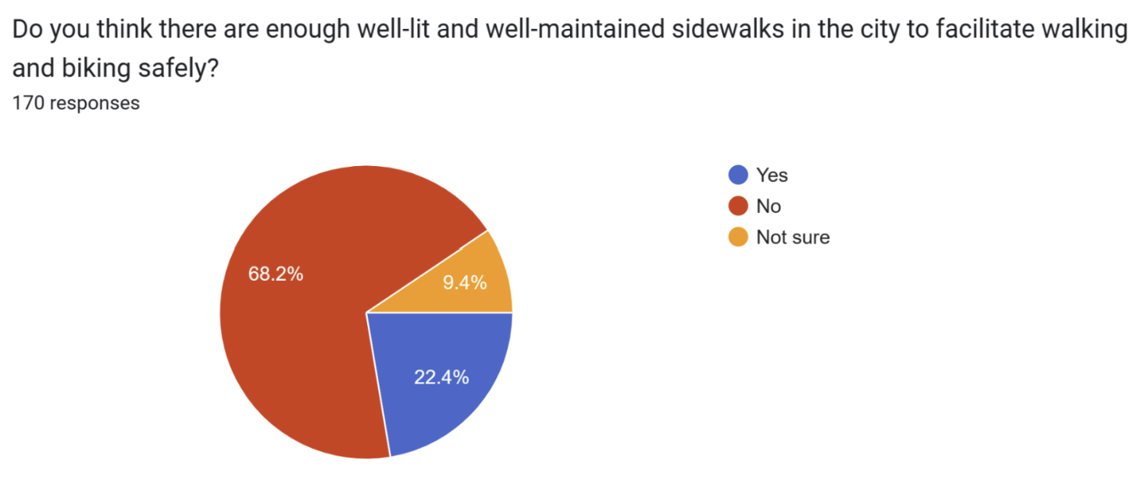
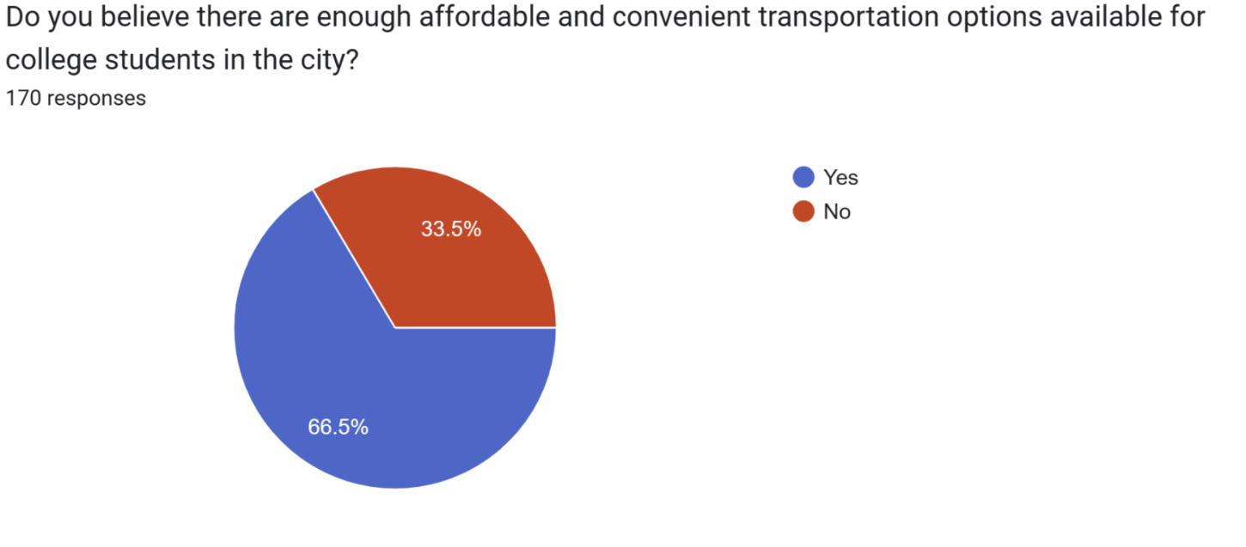
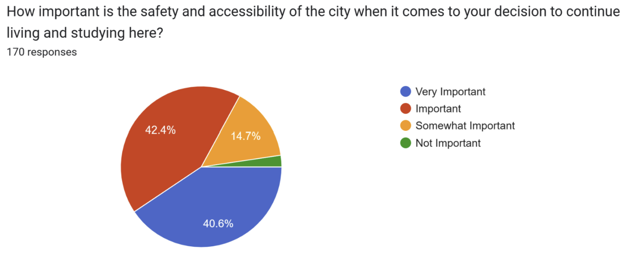

https://sga.wvu.edu/about/our-mission
https://safety.wvu.edu/
https://policies.wvu.edu/finalized-bog-rules/bog-governance-rule-1-6-rule
https://www-fars.nhtsa.dot.gov/states/statespedestrians.aspx
https://cdan.dot.gov/query
https://www.cdc.gov/injury/wisqars/fatal/trends.html
See Appendix A
See Appendix B
https://arcg.is/1fTqXC0
https://morgantownwv.maps.arcgis.com/apps/dashboards/a06645e8bea0419f8a6dd8eb345cc5 8b
See Executive Summary
https://www.access-board.gov/prowag/
https://www.ecfr.gov/current/title-36/chapter-XI/part-1191
https://safety.fhwa.dot.gov/ped_bike/tools_solve/fhwasa13037/research_report/chap2b.cfm
That sidewalks were the single biggest source of reports makes it necessary to understand the relevant legal and technical context.
https://www.plantogether.org/_files/ugd/613794_374f8ec74d1a46408dbc102bb2d25782.pdf

