West Virginia University

The Student Assembly - Student Government Association

Assembly Resolution: AP-2024-04-01

**AN ASSEMBLY PROCLAMATION TO ENCOURAGE INCREASED COMMUNICATION BETWEEN CITY COUNCIL AND SGA, AND TO SUPPORT VARIOUS SAFETY INITIATIVES**

| **Short Title:** | **Safety Recommendations** |  |
| --- | --- | --- |
| **Author(s):** | **Matthew Olivero, Senator** |  |
| **Sponsor(s):** | **Peyton Bielinski, College Senator (CAHS)**  **Joanna Switala, College Senator (Eberly)**  **Caitlin Shiels, College Senator (Eberly)**  **Garrett Oursler, College Senator (Davis)**  **Colin Street, Senator**  **Rozaireo Jones, College Senator (Reed)**  **Riley Coulter, College Senator (Statler)**  **Elijah Eastman, Senator**  **Daniel Madden, College Senator (Chambers)**  **Lilly Henson, College Senator (Eberly)**  **Mailyn Sadler, Senator** |  |
| **Contributor(s):** |  |  |
| **Committee Endorsement:** | **Student Life** |  |
| **First Reading Date:** | **4/3/2024** |  |
| **Second Reading Date:** | **4/10/2024** |  |
| **Date of Approval:** | **4/10/2024** |  |
| **Presidential Signature:** |  |  |

**Whereas,** the West Virginia University mission statement reads, "[we] commit to creating a diverse and inclusive culture that advances education, healthcare and prosperity for all by providing access and opportunity; by advancing high-impact research; and by leading transformation in West Virginia and the world through local, state and global engagement[1];” and,

**Whereas,** The West Virginia University Student Government Association’s (WVU SGA) mission statement reads that "We, the students of West Virginia University, desire to preserve within our University…an atmosphere that helps to foster an open exchange of ideas with civil discussion, inquiry, and self-expression to help ensure that the personal freedoms and general welfare of the students within our University are protected[2];” and,

**Whereas,** during the school year, WVU students comprise nearly half of the population of Morgantown[3],[4]; and,

**Whereas,** WVU SGA has a history of collaborating with Morgantown City Council on initiatives including safety and accessibility walks; and,

**Whereas,** apart from these walks, there is a lack of consistent communication between City Council and SGA, leading at times to confusion and misunderstandings; and,

**Whereas,** the City has created a sidewalk repair fund supported by property owners who do not wish to build their own sidewalks[5]; and,

**Whereas,** the safety and accessibility walks have consistently noted significant sidewalk damage across Morgantown[6]; and,

**Whereas,** WVU SGA is currently unaware of the implementation of this scheme or the fund’s status[7]; and,

**Whereas,** many WVU students continue to feel unsafe in Downtown Morgantown[8],[9]; and,

**Whereas,** there is a well-documented drug and homelessness problem in the city which affects perceptions of safety in the city and the area as a whole[10], [11]; and,

**Whereas,** it has been shown that harm reduction programs like Milan Puskar Health Right are safe and effective and do not cause drug use to increase or encourage more drug addiction[12]; and,

**Whereas,** reducing homelessness requires long-term planning that treats people dealing with homelessness as people rather than threats[13], [14]; and,

**Whereas,** the Bartlett House shelter, which housed 28 people, was recently denied further state funding, exacerbating the problem at hand.[15]

***Therefore, be it proclaimed by the Student Assembly of West Virginia University:***

**Section 1:** WVU SGA encourages the Morgantown City Council to continue and increase its engagement with SGA regarding safety and strategic planning;

**Section 2:** WVU SGA supports the implementation of the sidewalk waiver scheme proposed by the City;

**Section 3:** WVU SGA encourages the City to continue to support harm reduction programs like Milan Puskar Health Right;

**Section 4:** WVU SGA encourages the City to hasten its efforts to find a solution to homelessness which balances legitimate safety concerns with humanity and compassion for the homeless;

**Section 5:** WVU SGA calls upon the West Virginia Department of Health and Human Services to reconsider its decision to eliminate funding for the Bartlett House shelter;

**Section 6:** Upon passage and approval, this legislation shall be forwarded to the mandates below:

**Mandates:**

G. Corey Farris, Dean of Students

Dr. Thanh Le, Director, Student Engagement and Leadership

M. Joe Abu-Ghannam, 1st Ward, Morgantown City Council

Bill Kawecki, 2nd Ward, Morgantown City Council

Louise Michael, 3rd Ward, Morgantown City Council

Jennifer Selin, Mayor, City of Morgantown

Danielle Trumble, 5th Ward, Morgantown City Council

Dave Harshbarger, 6th Ward, Morgantown City Council

Brian Butcher, 7th Ward, Morgantown City Council

Ron Justice, Director, WVU Local Government Relations

Travis Mollohan, Asst. Vice President, WVU Government Relations

Madison Santmyer, Student Body President

Karsey Prichard, SGA Executive Secretary

The Daily Athenaeum

**APPENDIX A–CITY OF MORGANTOWN SAFETY SURVEY**

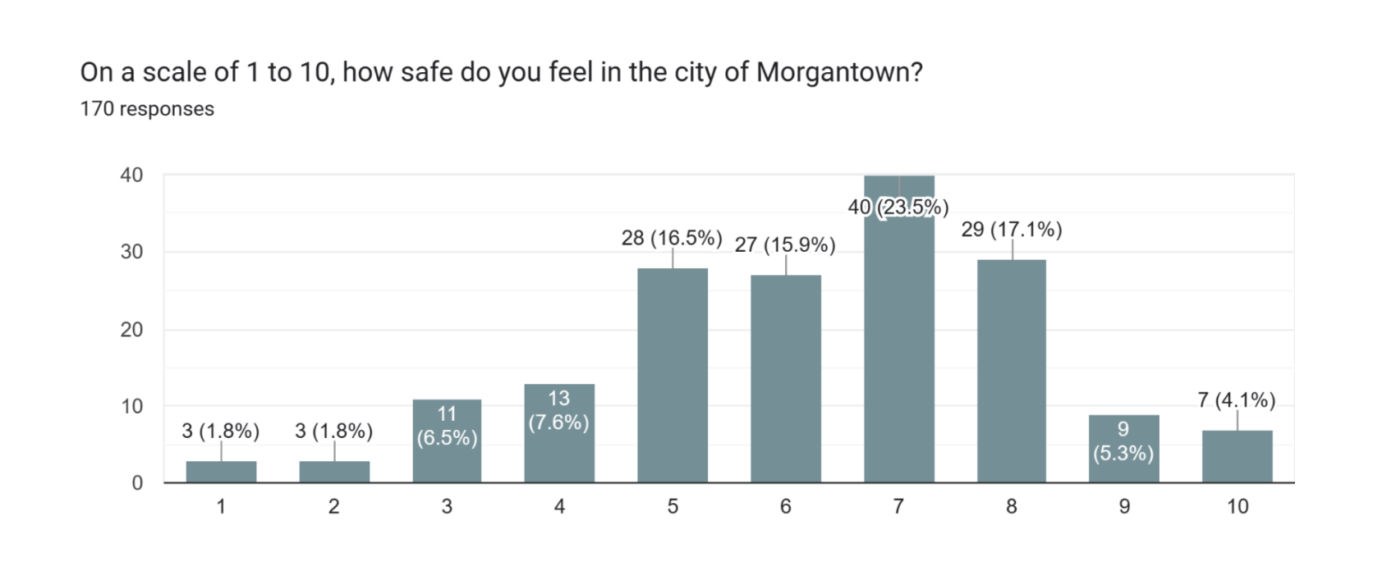

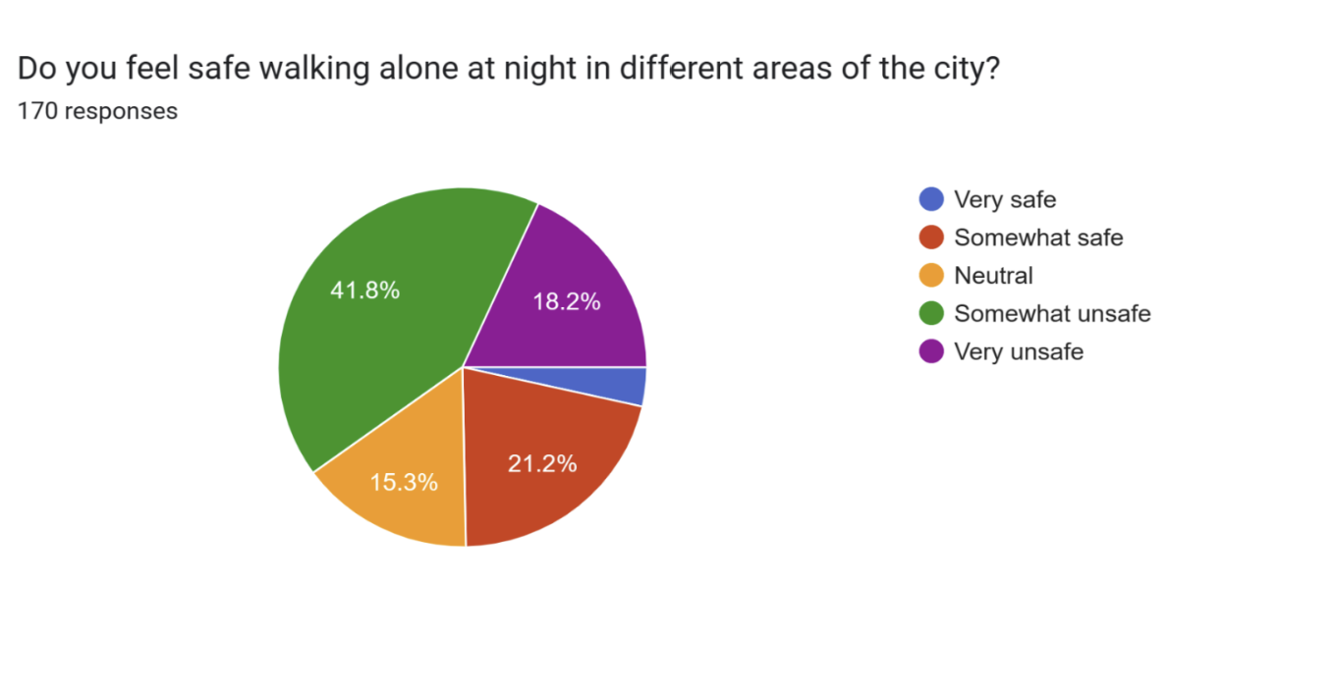

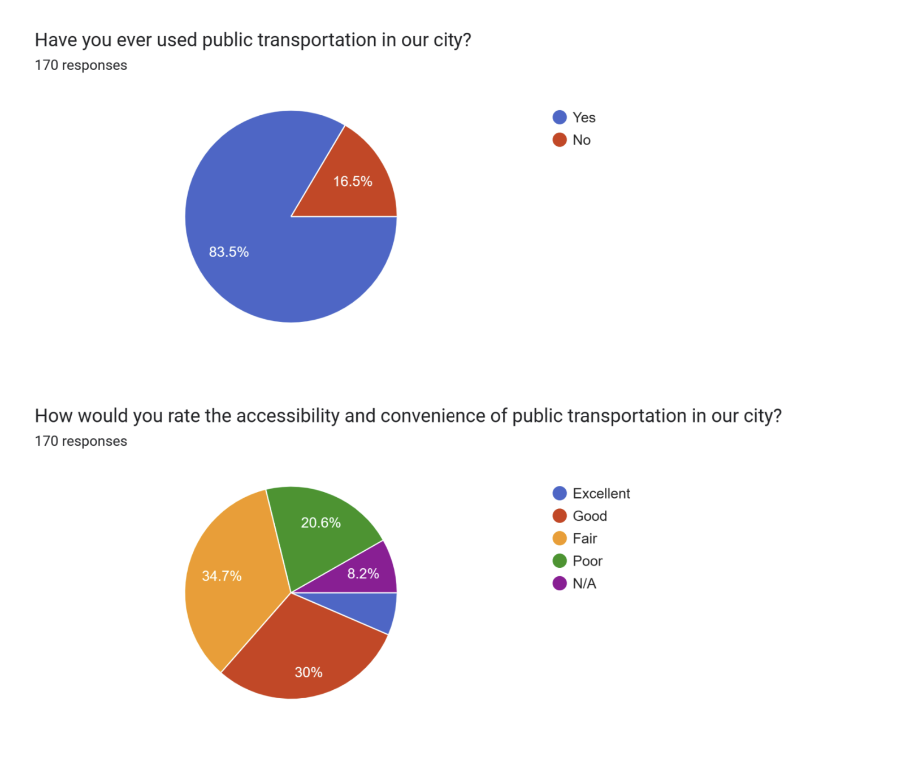

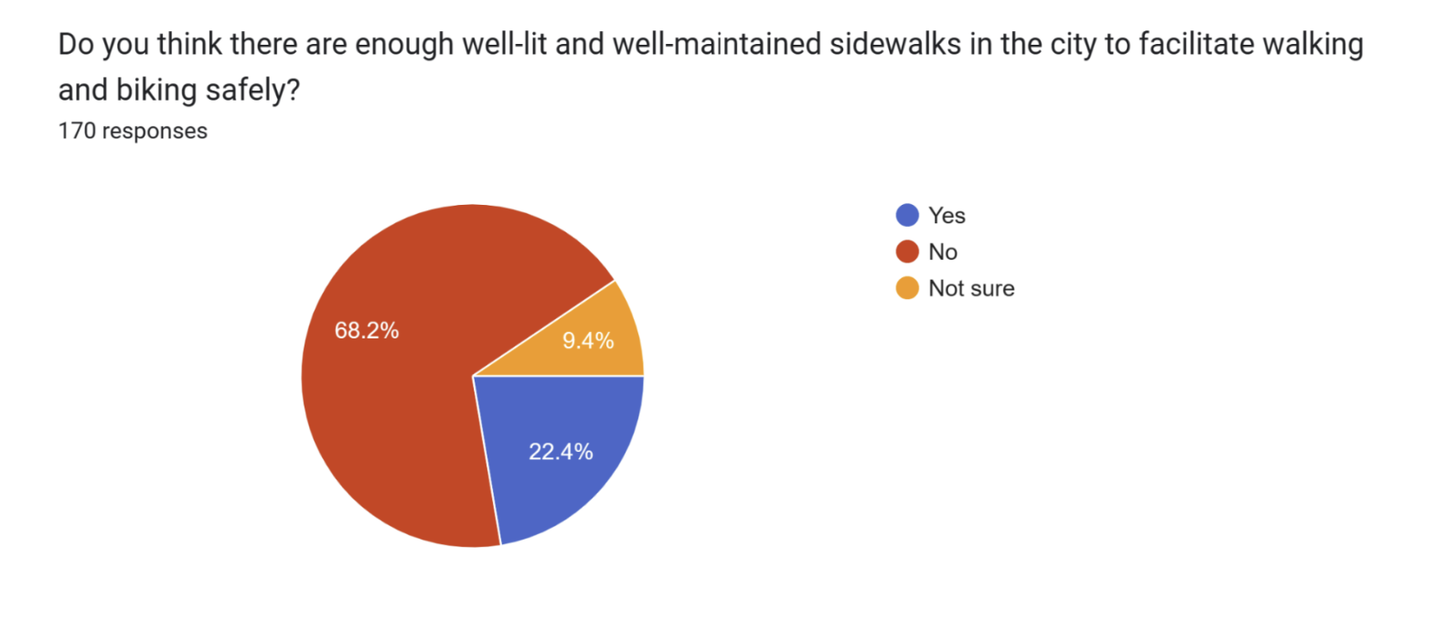

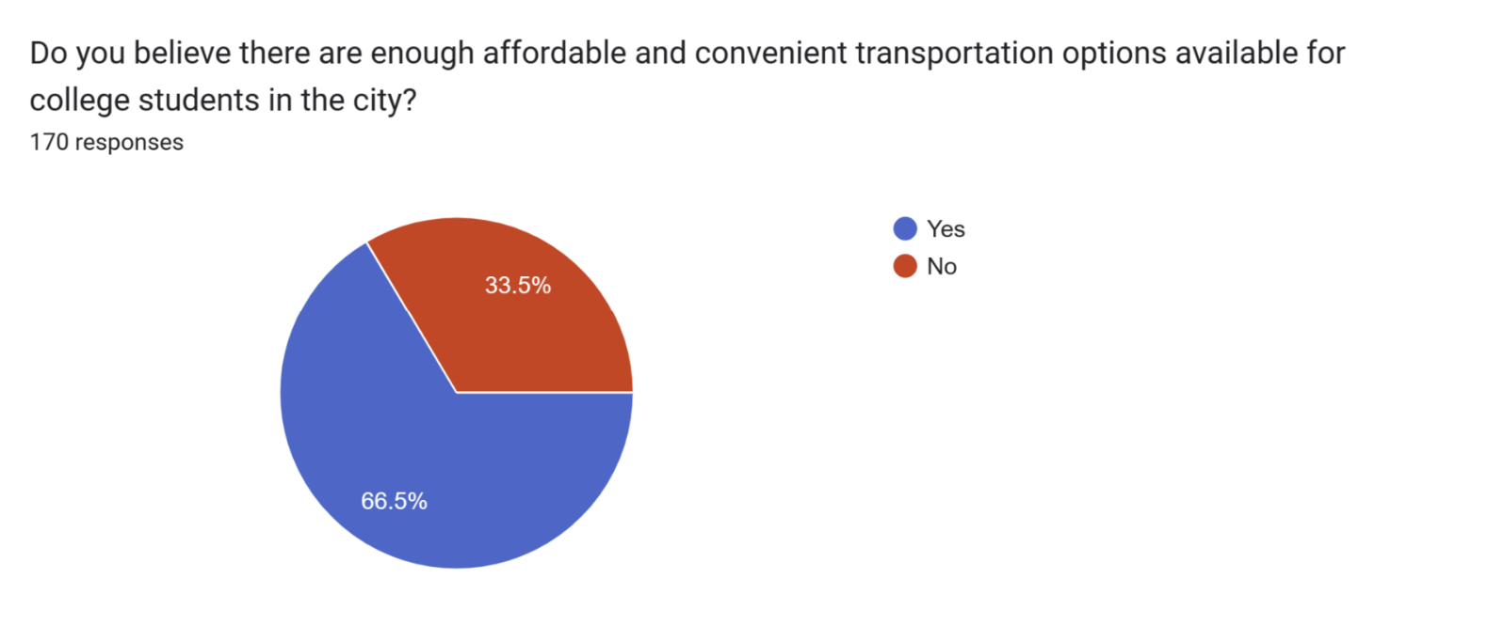

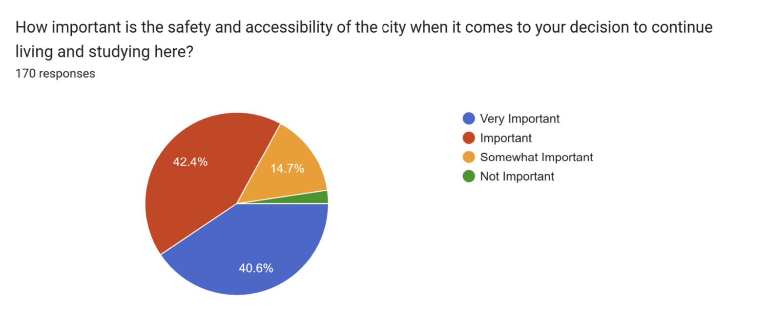

1. [WVU Mission Statement](https://www.wvu.edu/about-wvu/mission)
2. <https://sga.wvu.edu/about/our-mission>
3. <https://www.wvu.edu/about-wvu/wvu-facts>
4. <https://www.census.gov/quickfacts/fact/table/morgantowncitywestvirginia/PST045222>
5. <https://wajr.com/morgantown-to-pursue-improved-sidewalk-network/>
6. See, *inter alia*, AR-2023-12-01, AR-2023-01-08
7. This issue was raised at the Student Life Committee meeting with City Council on February 28th, although the record is unclear on whether or not the fund is currently operating.
8. *See* Appendix A
9. The WellWVU campus sentiment survey (n=1000) also found that students feel far less safe off campus than on it, although the results of that survey are not yet public.
10. <https://wvmetronews.com/2023/04/14/downtown-morgantown-business-owners-express-concerns-about-drugs-homeless-issues/>
11. <https://mountainstatespotlight.org/2022/12/08/homeless-unsheltered-west-virginia-winter/>
12. <https://nida.nih.gov/research-topics/syringe-services-programs#what-are-syringe>
13. <https://www.naco.org/articles/10-strategies-end-chronic-homelessness>
14. <https://endhomelessness.org/ending-homelessness/solutions/creating-systems-that-work/>
15. <https://www.wboy.com/news/monongalia/bartlett-housing-solutions-shelter-is-closing-morgantown-prepares-to-address-crisis/>