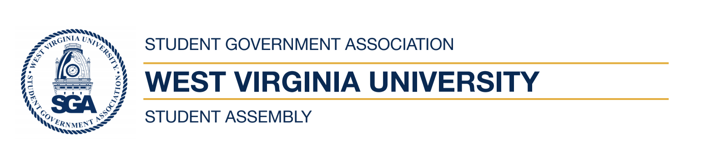
West Virginia University
Student Government Association
Regular Student Assembly Meeting
Zoom 7:30pm
September 16th, 2020

- Call to Order
- Reading of the SGA Mission Statement
- Roll Call
- Reading and Approval of the Agenda
- Reading and Approval of the Minutes
- Open Student Forum I
- The President’s Report
- Assembly Reports
- Executive Reports
- Old Business
- Second Reading of Legislation
  - AR-2020-12- Senator Daniel || Senator Ihlenfeld || Senator Harman
- New Business
- Executive Appointment Confirmation:
  - Chloe Hernandez, Health Coordinator
- FB-2020-07, Alex Cappadona, Treasurer
- AP-2020-06- Senator Nadeau || Senator Daniel || Senator Jernigan
- Open Student Forum II
- Advisors Report
- Adjournment

