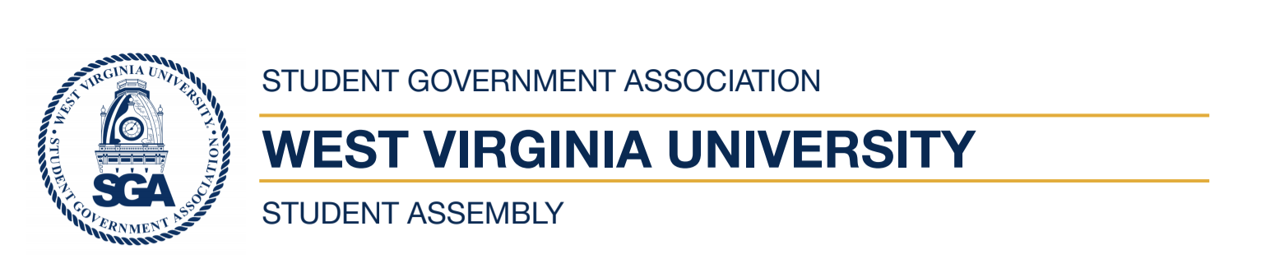
West Virginia University
Student Government Association
Regular Student Assembly Meeting
Zoom 7:30pm
September 23rd, 2020

- Call to Order
- Reading of the SGA Mission Statement
- Roll Call
- Reading and Approval of the Agenda
- Reading and Approval of the Minutes
- Open Student Forum I
- The President’s Report
- Assembly Reports
- Executive Reports
- New Business
  - FB-2020-08- Alex Cappadona, Treasurer
- Committee Sessions
- Open Student Forum II
- Advisors Report
- Adjournment

